 

***Unified Flag-Football***

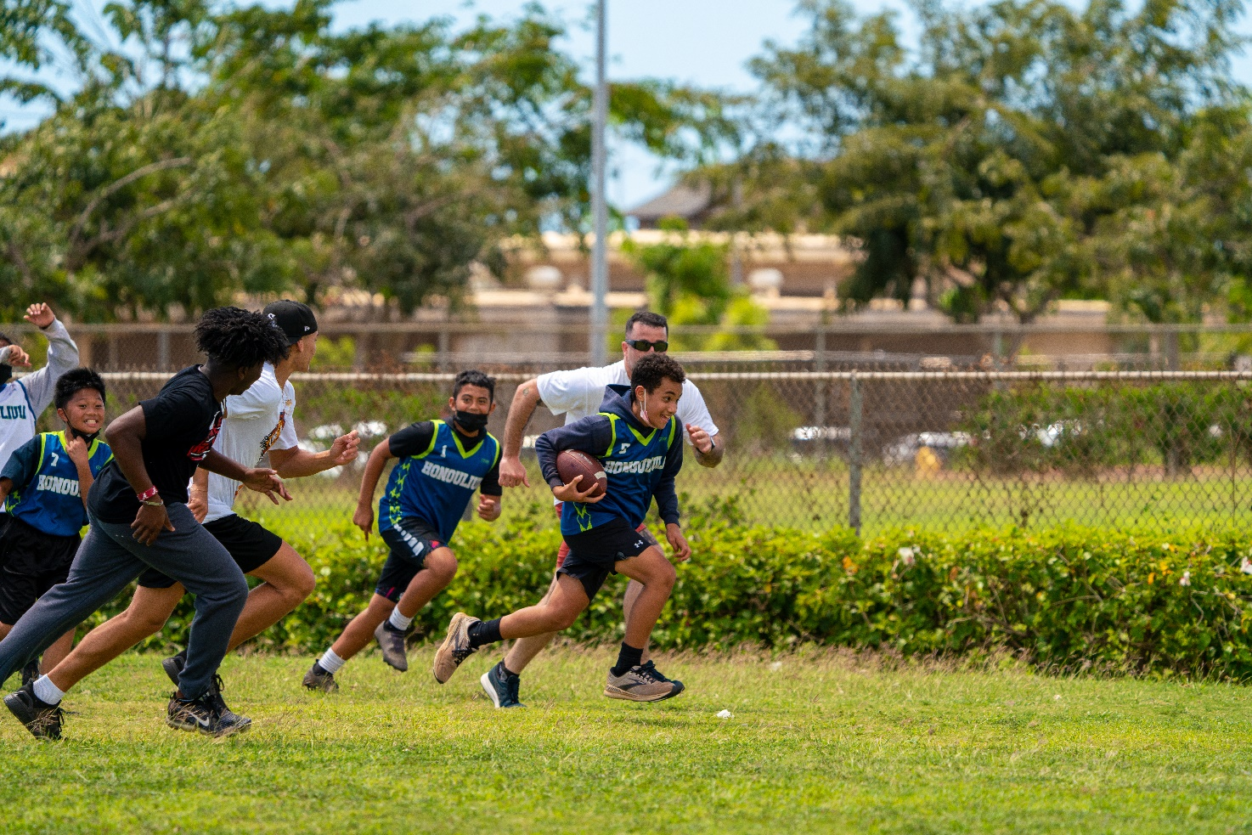

***Sport Information Guide***

***Rules and Guidelines***

***2026***

# Table of Contents

**SOHI FLAG FOOTBALL GUIDELINES AND RULES**

Page #

Section A - General Rules 3

Section B – Important Dates 4

Section C – Training Policy 4

Section D – Official Events 4

Section E – Divisions 5

Section F – Uniforms 5

Section G – Equipment 5

Section H – Rosters 6

Section I – Coaches Expectations 6

Section J – The Game 7-16

Overview 7

Field 8

Timing & Overtime 9

Live Ball/Dead Ball 10

Running 11

Passing/Receiving 12

Rushing the Passer 12

Screen Blocking 13

Flag Pulling 13

Formations 14

Unsportsmanlike Conduct 14

Penalties 15

Offensive Penalties and Protocol 15

Defensive Penalties and Protocol 15

Referee Call Signals 16

Section K – Unified 17

Section L – Terminology 19

Section M – Individual Skills Competition 20-26

Overview 20

Event: 40-Yard Dash 21

Event: Agility Run 22

Event: Passing 23

Event: Catching 24

Form: School ISC Roster 25

Assessment Sheet: 40-Yard Dash 26

Coaches Code of Conduct 27

Athletes/Unified Partners Code of Conduct 29

**SPECIAL OLYMPICS MISSION STATEMENT:**

The mission of Special Olympics is to provide year-round sports training and athletic competition in a variety of Olympic-type sports for children and adults with intellectual disabilities, giving them continuing opportunities to develop physical fitness, demonstrate courage, experience joy and participate in a sharing of gifts, skills and friendship with their families, other Special Olympics athletes and the community.

**Rule Changes, Additions, or Clarifications to Previous Rules**

**Section B** – 2026 Deadlines and Dates have been updated.

**Section M** – Individual Skills Competition Rules and Forms have been included.

**There will be no team component to the Individual Skills Competition.

For more information, please go to[**www.sohawaii.org**](http://www.sohawaii.org)or e-mail [**sohisports@sohawaii.org**](mailto:sohisports@sohawaii.org)**.**

# SOHI FLAG-FOOTBALL RULES AND REGULATIONS

# These Official Special Olympics Hawaii (SOHI) Rules shall govern all

# SOHI Flag-Football competitions.

# SECTION A – GENERAL RULES

1. Each Special Olympics Athlete is required to have a valid Medical form, filled out by a certified physician, and a signed Release form in order to participate. **Each Unified Partner must have a valid Unified Partner registration form**, and meet Class “A” Volunteer criteria in order to participate. Athletes or Partners without the appropriate forms are ineligible to participate. These forms must be on file with their Area Director and with the State Office.
2. All Coaches and Assistant Coaches must fill out a Volunteer Information Form and meet Class “A” Volunteer criteria in order to participate.
3. All Head Coaches and Assistant Coaches must complete NFHS or CDC Concussion Training, and submit certificate to SOHI.
4. All Unified Teams must have a Head Coach who has completed the Unified Sports Training.
5. For more information regarding Coaches Certification and Class A Volunteer requirements please see the following: [**https://secureservercdn.net/198.71.233.86/z20.966.myftpupload.com/wp-content/uploads/2022/02/Class-A-Volunteer-Information-2022-002.docx**](https://secureservercdn.net/198.71.233.86/z20.966.myftpupload.com/wp-content/uploads/2022/02/Class-A-Volunteer-Information-2022-002.docx)
6. Athletes and Unified Partners must participate in a training program run by a registered delegation. Athletes and Partners must comply with Delegation, Area, and State training policies and standards and must meet minimum attendance requirements set by the Delegation or Area to participate in Area, Regional, or State competition.
7. Each team is required to play in the qualifying tournament prior to participation in the final tournament. Only athletes who played in the qualifying tournament can play in the final tournament.
8. Each player must play at least 1 full series of downs in each game.
9. Injured players are not required to play. Players removed for disciplinary reasons are not required to play. Coaches must notify the scorekeeper prior to the game if players on the approved tournament roster will not be playing due to injury or disciplinary reasons.
10. Any player ejected from a game will be ineligible to play in the team’s next game.
11. No make-up games will be allowed to qualify athletes who have missed the qualifying competition.
12. Delegations with multiple teams should identify these teams with different team names, not numbers or letters.
13. All delegations must abide by the most current COVID Guidelines and Protocols.

# SECTION B – IMPORTANT DATES

|  |  |
| --- | --- |
| Event | Date/Deadline |
| Official Training May Begin |  |
| All Athletes must begin training/ All Medicals due/  Last day to transfer delegations |  |
| Registration Deadlines for qualifying Competition |  |
| Flag Football Officals Clinic | January 17, 2026 – SOHI Office |
| Official Training Must Begin for Delegations/Teams |  |
| Qualifying Competition |  |
| Final Competition | March, 2026 SOHI Office |

# 5

# SECTION C – TRAINING POLICY

1. Delegations must offer enough training sessions so that athletes have the opportunity to gain the skills and fitness levels required to be successful in their specific events.
2. Athletes **must** attend enough training sessions to gain the skills and fitness levels required to be successful in their specific events.
3. SOHI recommends that every athlete is offered at least two training opportunities per week with every training opportunity being at least 1 – 1 ½ hours in duration (Per the Global Strategic Plan). However, SOHI will accept a minimum of one training session a week for at least 90 minutes.
4. Area/Regional Competitions and scrimmages count as training sessions
5. SOHI requires that Athletes/ Unified Partners attend a minimum of 75% of training sessions offered by their delegation. Delegations may require a higher attendance percentage, but may not require athletes/Unified Partners to attend more than 90% of training sessions.
6. Athletes with documented injury or illness during a season may receive an exemption from the above policy, but must participate in a minimum of 50% of practices during the season and must have the requisite skills, and be physically capable (strength, fitness, injury/sickness fully healed with doctor’s clearance) of successfully participating in the sport as determined by their Head Coach. Athletes still must play at Area or Regional (qualifying) competition in order to compete at the Final Competition.

# SECTION D – OFFICIAL EVENTS

* Five-a-Side Unified Team Competition
* Individual Skills Competition

# SECTION E – DIVISIONS

Unified Team Divisions will be created based on the School/Age level of the team.

1. Separate divisions will be created for High School Teams. Unified Flag Football is currently not available for adults at this time.
2. Separate divisions may be created within a school/age level if there are enough teams and if there is a great disparity among the skill levels of the teams within their school/age level.
3. Unified Teams are still required to complete the assessment tests and follow all Division guidelines above.

# SECTION F – UNIFORMS

1. All players must wear numbered uniforms. Only the digits 0-5 may be used with the highest possible number being 55. Numbers are required on both sides of the jersey and shall be at least 6 inches high on the back and 4 inches high on the front, and not less than ¾ inch in width.
2. All players must wear closed toed shoes.
3. All members of a team must wear the same color uniform jersey. If a T-shirt is worn under a tank top, it should be the same or a similar color. (No cut or ragged edges).
4. All players should wear gym shorts of the same color. Players cannot wear jeans or cutoffs. Sweatpants may be worn for religious or custom related reasons.
5. Those players who wear eyeglasses while playing are required to wear a strap to hold the glasses in place.
6. All athletes must remove all jewelry, watches, bracelets, earrings, necklaces, rings, etc. prior to each game.
7. Head coverings are for religious reasons only and must be of a single, solid color, and unadorned.
8. If a medical device is worn, it must be approved prior to competition. This includes any device worn that covers the face, lower arm (from the elbow to the wrist), knee, or lower leg. A document from a Doctor indicating the purpose and composition of the device will assist in addressing any risk management issues.

# SECTION G – EQUIPMENT

1. An intermediate (youth) size football will be used in all divisions.
2. A protective mouthpiece must be worn at all times.
3. A one-piece, three-flag belt will be worn during the game at all times.
4. Players must wear rubber-cleated or flat soled athletic shoes.
   1. Metal cleats, spikes, hiking boots, or other equipment deemed dangerous by officials will not be allowed.

# SECTION H – ROSTERS

Unified Sports Teams

1. The team roster may contain a maximum of 12 players.
2. The roster shall contain a proportionate number of athletes and partners.
3. During competition, teams shall field five (5) players to start the game (required).
   1. The line-up shall never exceed three (3) athletes and two (2) partners at any time.
   2. Teams may continue with a minimum of four (4) players (minus 1 partner or athlete) due to disqualification or injury.
4. Failure to adhere to the required ratio results in a forfeit.

# SECTION I – COACHES EXPECTATIONS

1. Coaches are typically volunteer parents, friends, or family members helping the players learn and enjoy the game. Parents are **strongly** encouraged to support the coach at all times.
2. Coaches are expected to adhere to the Special Olympics rules and philosophies, coach’s guidelines, and code of conduct.
3. Coaches must have the following certifications to participate:
   1. General Orientation
   2. Protective Behaviors
   3. Class A Volunteer form, which allows SOHI to do a background check
   4. Unified Sports Online Training
   5. (Head coaches, per team – not school, only) Attend Flag-Football Coaches Clinic

# SECTION J – THE GAME

### Overview

1. Special Olympics Flag Football is non-contact.
   1. In all aspects of Special Olympics Flag Football, rulings shall be made with player safety as the primary consideration.
2. Teams shall field five (5) players to start the game (required).
   1. Teams may continue with a minimum of four (4) players, if necessary due to disqualification or injury.
3. Teams will be grouped in divisions based on a classification round of games, skills assessment scores, or past competitions.
4. Points of Emphasis
   1. No team shall repeatedly commit penalties/fouls, which will halve the distance to the goal line.
   2. Neither team shall commit any act, which, in the opinion of the referee, tends to make a travesty of the game. This includes intentionally committing penalties/fouls to gain an advantage.
   3. The referee will enforce any penalty he/she considers equitable, including the award of a score for an unfair act.
5. Coin Toss
   1. A coin toss determines first possession.
   2. Each team will provide two (2) captains, one (1) athlete and one (1) partner.
   3. The officials and team captains will meet three (3) minutes prior to the start of the contest to conduct the coin toss.
   4. The winner of the coin toss will choose offense, defense, or end of field to defend. The team winning the coin toss may defer its choice to the second half.
6. Possessions
   1. All possessions, except following an interception, start at the offensive team’s 5-yard line.
   2. The offense has four (4) plays to cross mid-field.
   3. Once the offense crosses mid-field, they have four (4) additional plays to score a touchdown.
   4. If the offensive team fails to cross mid-field or score a touchdown in a prescribed number of plays, possession of the ball changes and the opposite team starts at their 5-yard line.
   5. The ball carrier may not spin, dive, hurdle, stiff-arm, or use either arm to shield a defender from grasping his/her flag.
   6. The ball is marked at the spot of the ball when the player is declared down (when the carrier’s flag belt is pulled or hand/knee touches ground).

### Field

1. The playing field is 60 yards long (including the end zones) and 25 yards wide. If insufficient space is available, a slightly smaller space can be used. A space of at least 5 yards around the field must be free and clear of obstructions. The field can be marked with chalk, paint, and/or traffic cones.
2. No-Run Zones are in place to prevent teams from conducting power run plays. While in the No-Run Zones (a 5-yard imaginary zone before midfield and before the end zone), teams cannot run the ball in any fashion. All plays must be pass plays, even with a handoff.
3. Stepping on a boundary line is considered out of bounds.
4. Each offensive team approaches only TWO (2) No-Run Zones in each drive (a 5- yard zone before midfield to gain the first down and before the end zone, 5 yards from the goal line to score a TD).

*Diagram of Flag Football field*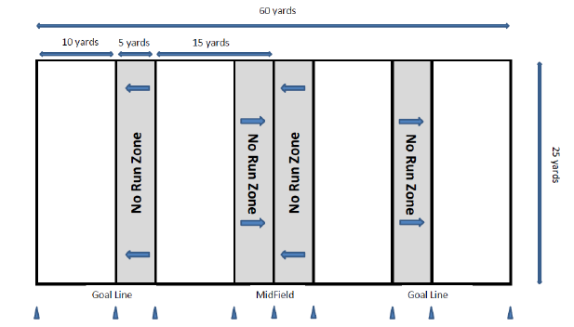

### Timing & Overtime

Timing

1. The game shall consist of two (2) 20-munite halves (running time) until the last minute of each half at which time the clock will stop on all dead ball whistles (i.e. incomplete pass, out of bounds, change of possession).
2. Officials can stop the clock at their discretion (injuries, delays).
3. The clock will stop on all time-outs.
4. Each team receives one (1) 60-second time-out per half.
   1. An unused time-out in the first half does not carry over to the second half.
5. There shall be a 5-minute break at halftime.
6. The ball must be put in play promptly and legally and any action or lack of action by either team that tends to prevent this is considered a delay of game.
7. This includes:
   1. Interrupting the 30-second count for any reason except for a granted time-out,
   2. Consuming more than 30-seconds to snap the ball after it is ready for play,
   3. Failing to remove an injured player for whose benefit an excess time-out has been granted, or
   4. Deliberately advancing the ball after it has been declared dead.

Overtime

1. If the score is tied at the end of regulation play:
   1. A coin toss is held to determine first possession.
   2. Each team receives two (2) plays from midfield and the team gaining the most points or gaining a yardage advantage is awarded one (1) extra point and wins the game.
   3. Exceptions to this rule are as follows:

Interception: The team that intercepts the pass automatically wins the game.

1. If the team with the first attempt in overtime scores on the first play, the opposing team must score on its first play also. If both teams score a touchdown, or gain the same yardage, the procedure is repeated until one (1) team wins.

### Scoring

* 1. **Touchdown**: six (6) points
  2. **Extra point**: one (1) point from the 5-yard line, two (2) points from the 12-yard line.
  3. **Safety**: two (2) points
  4. **Mercy Rule** – if a team is up 25 or more points in the last minute of the game, the clock will continue to run

### Live Ball/Dead Ball

1. Positions/Snap
   1. The ball may be snapped between the Center’s legs, **or to the side,** to start each play.
   2. No minimum number of players is required to line-up on the line of scrimmage.
2. Dead Balls/Fumbles
   1. There are no fumbles.
   2. Play is ruled dead when:
      1. The ball carrier’s flag is pulled;
      2. The ball carrier loses his/her flag;
      3. The ball carrier steps out of bounds;
      4. The ball carrier’s knee or hand touches the ground;
      5. A touchdown, extra point, or safety is scored;
      6. When during a try-for-point the defense obtains possession of the ball;
      7. When a forward pass strikes the ground or is caught simultaneously by opposing players (the offense retains possession);
      8. A pass is intercepted (no returns);
      9. A receiver catches a ball without his/her flags attached;
      10. A snapped ball touches the ground;
      11. If fumbled forward, the ball is spotted where the ball carrier’s feet were at the time of the fumble. If the ball falls backwards, it is marked where it hits the ground;
      12. When there is an inadvertent whistle.
3. Inadvertent Whistle
   1. In case of an inadvertent whistle, the team in possession of the ball may choose to accept the result of the play at the point where the play was blown dead or choose to re-play the down.
4. Substitutions (Athlete for Athlete/Partner for Partner)
   1. Any player on the roster may enter upon the completion of a play (Dead Ball).
   2. Each substitute must play at least one (1) down prior to being replaced.
   3. A replaced player must leave the field immediately.
5. Delay of Game
   1. The ball must be put in play promptly and legally and any action or lack of action by either team that tends to prevent this is considered a delay of game.
   2. This includes:
      1. Interrupting 30-second count for any reason except for a granted time-out,
      2. Consuming more than 30-seconds to snap the ball after it is ready for play,
      3. Failing to remove an injured player for whose benefit an excess time-out has been granted, or
      4. Deliberately advancing the ball after it has been declared dead.
6. False Start
   1. No member of the offensive team may simulate the start of the play before the ball is snapped.

### Running

1. Handling the ball by the offense
   1. Handling the ball is transferring player possession from one teammate to another without throwing or kicking it.
   2. Direct handoffs and one lateral (a backward pass) behind the line of scrimmage are permitted. Handoffs may be in front, behind, or to the side of the quarterback/offensive player, but must be behind the line of scrimmage. Laterals cannot be from partner to partner.
   3. The offense may use multiple handoffs behind the line of scrimmage. Only one lateral may be used behind the line of scrimmage.
   4. “**Center Sneak” –** The ball must completely leave the center’s hands on the snap and he/she must step backwards off the line of scrimmage in order to receive the direct handoff from the quarterback/offensive player before advancing the ball.
2. Running
   1. **The Quarterback (first player gaining possession of the snap) cannot advance the ball across the line of scrimmage.**
   2. Direct hand-offs behind the line of scrimmage are legal. One lateral or pitch (legally known as a backward pass) is allowed behind the line of scrimmage. A lateral cannot be from a partner to partner.
      1. In Unified Sports® divisions, a partner may handoff to a partner behind the line of scrimmage.
   3. The player who takes a hand-off can pass the ball, as long as he/she does not pass the line of scrimmage.
   4. “No Running Zones” are located 5-yards before the mid-field line and goal line.
      1. Any ball snapped from these zones must be passed.
      2. The purpose of “No Running Zones” is to avoid short yardage power running situations.
   5. The ball carrier may not spin, dive, hurdle, stiff arm, or use either arm to shield a defender from grasping his/her flag.
   6. The ball is marked at the spot where the position of the ball is when the player is declared down (carrier’s flag belt is pulled or hand/knee touches ground).
3. Hurdling
   1. Jumping over or attempting to jump over a player, by the ball carrier, to prevent from being downed or to gain additional yardage is illegal.
      1. Note: Jumping over a player who is on the ground to avoid injury, by official’s judgment, is legal.
4. Shielding (Flag Guarding)
   1. Runners shall not shield (flag guard) by using their hands, arms, or the ball to deny the opportunity for an opponent to pull or remove their flag belt.
   2. This includes:
      1. Swinging the hand or arm over the flag belt;
      2. Stiff arms;
      3. Placing the ball in a possession over the flag belt; and
      4. Lowering the shoulders or arm over the flag belt.
      5. Hurdling.

### Passing/Receiving

1. Passing and Receiving by the offense.
   1. All passes must be forward and received beyond the line of scrimmage.
   2. Shovel passes are allowed, but must be received beyond the line of scrimmage.
   3. All players are eligible to receive a forward pass, including the Quarterback, if he/she has legally handed-off.
      1. Exception: In Unified Sports® divisions, if a partner throws a pass, only athletes are eligible receivers.
   4. Only one (1) player is allowed in motion at the snap and he/she may not be moving toward the line of scrimmage at the snap.
   5. A player must have at least one (1) foot in bounds when making a catch.
   6. Interceptions change possession of the ball at the point of the interception.
      1. Exception: A ball intercepted in the end zone is spotted at the 5-yard line.
2. Diving
   1. A defensive or offensive player may dive to catch a pass.
   2. Diving is illegal when used to down a player or advance a ball.
   3. A player cannot dive in an attempt to gain extra yardage.
   4. The team will be penalized accordingly.
3. Eligible Receiver
   1. All offensive players are eligible to receive a pass, except in Unified Sports® divisions where partners are ineligible when partners are throwing the pass.
      1. Unified Sports® teams are expected to comply with this rule without intervention by officials.
   2. Failure to “self-patrol” will be considered unsportsmanlike, and will be penalized accordingly.

### Rushing the Passer

1. Rushing the Quarterback by defensive players (QB).
   1. All players who rush the Quarterback must be a minimum of 7-yard from the line of scrimmage when the ball is snapped.
      1. A special marker, placed by the official, will designate the spot 7-yards from the line scrimmage when the ball is snapped.
   2. Players not rushing the quarterback may defend the line of scrimmage.
   3. Once the Quarterback hands off the ball, the 7-yard zone no longer exists, and all defenders are eligible to rush.

### Screen Blocking

1. Screen blocking
   1. Legally obstructing an opponent without contacting him/her with any part of the screen blocker’s body.
   2. The screen blocker shall have his/her arms fully extended to the ground (below the waist) either at his/her side, in front, or behind his/her back.
   3. Any use of arms, elbows, legs, or shoulders to initiate contact during the screen block is illegal.
   4. A player must be on his/her feet before, during, and after screen blocking.
   5. Screen blocking is the only form of legal blocking that can be used by any player at any time.
   6. There are two form of legal blocking:

**Backfield Blocking:** If any of the provisions listed are violated, and contact results, the screener has committed an illegal block.

* + 1. The screen blocker must give an opponent at least one (1) step.
    2. The screen blocker must not initiate contact with opponent.
    3. The screen blocker may not take a position so close to a moving opponent that this opponent cannot avoid contact by stopping or changing directions.
    4. After the snap of the ball, a blocker may move laterally or backward two (2) steps.

**Downfield Blocking:** A basketball style (non-moving) screen is the only acceptable form of downfield blocking. The blocker also may not run between a rusher and ball carrier impeding a defender’s progress to the flag.

### Flag Pulling

1. A legal flag pull takes place when the ball carrier is in full possession of the ball.
2. It is illegal to pull or strip the ball from the carrier’s possession at any time (penalty).
3. If a player’s flag belt inadvertently falls off during the play, the player is down immediately upon possession of the ball and the play ends
4. A defensive player may not intentionally pull the flags off of a player who is not in possession of the ball (penalty).
5. Flag Guarding/Shielding is an attempt by the ball carrier to obstruct the defense’s access to the flags by stiff arming, dropping the head or shoulder, or intentionally covering the flags with the football jersey.

### Formations

1. Line of Scrimmage
   1. The line of scrimmage for each team is a vertical plane through the point of the ball nearest the team’s goal line.
   2. Each player on a team must be on its side of the line of scrimmage when the ball is snapped.
2. Motion
   1. Only one player of the offensive team may be in motion at the snap.
      1. This player must be behind the line of scrimmage and not moving toward the line of scrimmage at the time the ball is snapped.
      2. If the player comes to a stop he/she must be set for one (1) second.
3. Shift
   1. A shift is the action of one (1) or more offensive players who after taking set positions move to a new position prior to the snap.
   2. A player who shifts must reset for one (1) second prior to the snap.
4. Snap
5. A snap is the legal act of passing the ball through the Center’s legs or to the side of Center’s legs from the ground to the Quarterback to start a play.

### Unsportsmanlike Conduct

1. Sportsmanship/Roughing
   1. The officials will disqualify any player who participates in rough or unsportsmanlike play.
   2. During player possession, it is illegal for a defensive player to strip or pull the ball from the ball carrier at any time.
   3. No warning is required.
2. Ball carriers *MUST* make an effort to avoid defenders with an established position.
3. Defenders are not allowed to run through the ball carrier when pulling flags.

### Penalties

1. Penalties
   1. Coach's will have the opportunity to decline or accept the penalty based on result of the play.
   2. The penalty may be accepted while the yardage is declined.
   3. All penalties are assessed from the line of scrimmage.
   4. No penalty may take the ball more than half the distance to the offender’s goal line.
   5. Offense: 10-yards from the line of scrimmage and loss of down
      1. Illegal Motion (more than one (1) player moving at snap, moving forward at snap);
      2. Offside (in neutral zone at snap, false start);
      3. Illegal forward/backward pass (pass not completed beyond line of scrimmage; illegal backward pass; Partner to Partner; QB pass beyond line of scrimmage);
      4. Illegal Procedure (quarterback run);
      5. Pass Interference (picking or pushing defender);
      6. Illegal Contact (holding, blocking, bumping, stiff arming);
      7. Flag Guarding (driving, spinning, warding off, hurdling); and
      8. Delay of Game (failing to snap within 30 second of ready).
   6. Defense: 10-yards from the line of scrimmage and automatic first down
      1. Offside (in or beyond neutral zone at snap);
      2. Pass Interference;
      3. **Illegal Contact (holding, blocking, bumping, stripping);**
      4. Illegal Flag Pull (before receiver has ball); and
      5. Illegal Rushing (rushing Quarterback inside 7-yard line).

### Offensive Penalties and Protocol

|  |  |
| --- | --- |
| Illegal motion offside | 10 yards from line of scrimmage & loss of down |
| Illegal forward/backward pass | 10 yards from line of scrimmage & loss of down |
| Illegal procedure | 10 yards from line of scrimmage & loss of down |
| Pass interference | 10 yards from line of scrimmage & loss of down |
| Illegal contact | 10 yards from line of scrimmage & loss of down |
| Flag guarding/shielding | 10 yards from line of scrimmage & loss of down |
| Delay of Game | 10 yards from line of scrimmage & loss of down |

### Defensive Penalties and Protocol

|  |  |
| --- | --- |
| Offside | 10 yards from line of scrimmage & automatic first down |
| Pass interference | 10 yards from line of scrimmage & automatic first down |
| Illegal contact | 10 yards from line of scrimmage & automatic first down |
| Illegal flag pull | 10 yards from line of scrimmage & automatic first down |
| Illegal rushing | 10 yards from line of scrimmage & automatic first down |

### Referee Call Signals

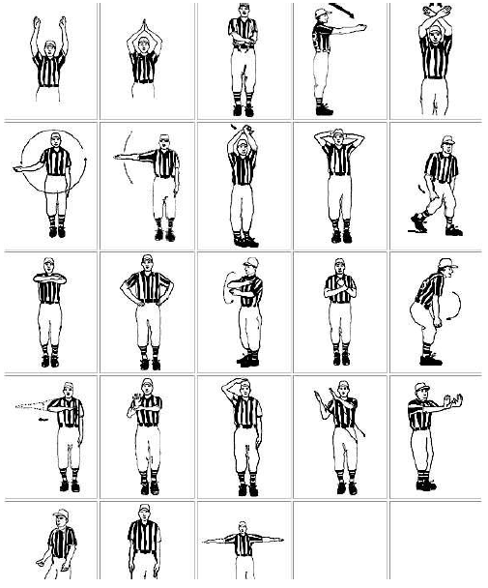

# SECTION K – UNIFIED

1. The roster shall contain a proportionate number of athletes and partners.
2. During competition, teams shall field five (5) players to start the game (required).
   1. The line-up shall never exceed three (3) athletes and two (2) partners at any time.
   2. Teams may continue with a minimum of four (4) players (minus 1 partner or athlete) due to disqualification or injury.
   3. A team will forfeit with less than four (4) eligible players.
3. Failure to adhere to the required ratio results in a forfeit.
4. Each team shall have an adult non-playing coach responsible for the line-up and conduct of the team during competition.
5. Partners as quarterbacks may NOT pass to another partner.
6. Partners MAY handoff to another partner.
7. Partners may not lateral to another partner.
8. Partners may NOT dominate play.
   1. 1st offense results in a warning.
   2. 2nd offense results in the partner’s removal from the game.
9. Athletes **must** wear even number uniforms; Unified Partners **must** wear odd number uniforms.
10. Every player must be meaningfully involved in the team. This means that every player must be given an opportunity to contribute to the success of his or her team through their unique skills and qualities. Every teammate: (a) demonstrates sufficient sport-specific skills and game understanding; (b) plays a valued role on the team that emphasizes his or her personal talents; and (c) has an opportunity to play without a heightened risk of injury.
11. Team members should be made up of athletes and partners who are of similar ages and ability levels. In consideration of safety and dominant play, individuals with significantly greater skill than the majority of their teammates may be prohibited from competing during competition
12. All players on a Unified Sports team make the commitment to attend every practice, support each other as equal teammates, and demonstrate respect and sportsmanship.

# SECTION L – TERMINOLOGY

|  |  |
| --- | --- |
| Center | Player that snaps ball through legs to begin play |
| Dead ball | Refers to the period of time immediately before or after the play |
| Defense | The team opposing the offense to prevent them from advancing the ball |
| Defer | Winner of Coin toss is giving the choice to the other team for the first half of the game. The winner of the coin toss gets choice in the second half |
| Downs (1,2,3,4) | The offensive squad has 4 attempts or “downs” to advance the ball. They must cross midfield to get another 4 “downs” to score |
| Inadvertent Whistle | Official’s whistle that is a performed in error |
| Lateral/pitch | A BACKWARD PASS of the ball by the ball carrier |
| Line of Scrimmage | (LOS) an imaginary line running through the point of the football and across the width of the field |
| Live ball | Refers to the period of time that the play is in action. Generally used in regard to penalties, live ball penalties are considered part of the play and must be enforced before the down is considered complete |
| No Run Zones | Areas of the field where teams can only pass the ball |
| Offense | The team with possession of the ball |
| Out of Bounds | The outer perimeter line of the field. They include the sidelines and the back of the end zone lines |
| Passer | The offensive player that throws the ball and may or may not be the quarterback |
| Quarterback | The offensive player first receiving possession of the ball. The quarterback may not run the ball |
| Rush Line | An imaginary line running across the width of the field 7 yards (into the defensive side) from the line of the scrimmage |
| Rusher | The defensive player(s) assigned to rush the quarterback to prevent him/her from passing the ball by pulling his/her flags or by blocking the pass |
| Screen Blocking | A legal obstruction of an opponent without contacting him/her with any part of the screen blocker’s body |
| Shielding (Flag Guarding) | An act by the ball carrier to prevent a defender from pulling the ball carrier’s flags by stiff arm, lowering elbow or head, or by blocking access to the runner’s flags with a hand or arm. |
| Shift | A shift is the action of one or more offensive players who after taking positions move to a new position prior to the snap. |
| Shovel Pass | A legal pass attempted beyond the line of scrimmage by throwing the ball underhand or pushing it towards a receiver in a shot put type manner |
| Unsportsmanlike Conduct | A rude, confrontational, or offensive behavior or language |
| Whistle | Sound made by an official using the whistle that signals the start/end of play or a stop in the action for a timeout, half time, or the end of the game |

# SECTION M – INDIVIDUAL SKILLS COMPETITION

### Overview

1. The Individual Skills Competition is designed specifically for athletes with lower abilities who are not proficient in the basic fundamental skills required to safely and meaningfully participate in team play. The Individual Skills Competition should be conducted in the same professional manner and with the same excitement as the team flag-football competition.
2. For the 2023 Unified Champion Schools Flag-Football season, the Individual Skills Competition will be held at all league play and competition events. Athletes will train and compete in four different skills: Speed (40-Yard Dash), Agility, Passing, and Catching.

### Registration

1. All athletes must be registered before the competition with the Unified Champions School Manager by January 23, 2023, via e-mail: [unify@sohawaii.org](mailto:unify@sohawaii.org).

### Divisioning

1. Athletes are grouped into divisions using assessment scores submitted by their coaches.
2. Divisioning for the Individual Skills’ first event will be done by using the 40-Yard Dash assessment score.
3. All teams must submit assessment scores, as part of their registration, to the Unified Champions School Manager by February 17, 2023, (found on pg. 26), via e-mail: [unify@sohawaii.org](mailto:unify@sohawaii.org).
4. Combined event scores will be used for the final competition divisions.
5. For each event, athletes will be in competition divisions of three to eight, made, all scores within a division would fall within 10%.
6. Each division is given a Division Escort responsible for moving the athletes from event to event, carrying the scorecards or division score sheet, and readying the “on-deck” athlete.

Buddies

1. Teams may provide student buddies to “assist” athletes during the event.
2. Buddies must be registered Unified Partners.

**EVENT #1: 40-YARD DASH (SPEED)**

**Purpose:** To measure participant’s speed.

**Equipment:** Stopwatch, measuring tape and cones.

**Set-Up:** Measure 40-yards from one cone/start to the other cone/finish.

**Video Link:** <https://www.youtube.com/watch?v=DgIgzmVkf7o&t=23s>

**Instructions:** Participant’s will begin at the starting line. When the official announces “On Your Mark, Get Set, Go”, participant will run 40-yards as fast as they can to the finish line. Points will be determined by participant’s time.

**Scoring:** Each participant will have one attempt at this event and the scoring will be as followed (see scoring chart below).

|  |  |
| --- | --- |
| **SECONDS** | **POINTS** |
| 6-8 | 4 |
| 9-10 | 3 |
| 11-12 | 2 |
| 12 & Slower | 1 |

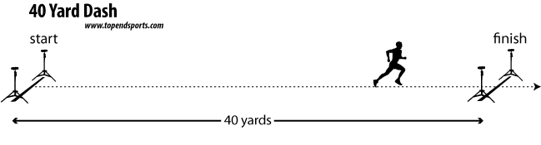

**EVENT #2: AGILITY RUN WITH THE FOOTBALL**

**Purpose:** To measure participant’s ability to run and turn at a fast pace.

**Equipment:** Cones, an intermediate (youth) size football, measuring tape and a stopwatch.

**Set-Up:** Place the cones 10-yards apart in a zigzag formation.

**Video Link:** <https://www.youtube.com/watch?v=_oJRFrj_gVc>

**Instructions:** Participant will begin at the starting line. When the official announces “On Your Mark, Get Set, Go” the participant will run as fast as possible, carrying the football to the closest cone, running around the cone, heading to the second cone diagonally. They will follow this pattern through four cones and sprint to the finish line. Points will be determined by participant’s time.

**Scoring:** Each athlete will have one attempt at this event and the scoring will be as followed (see scoring chart below).

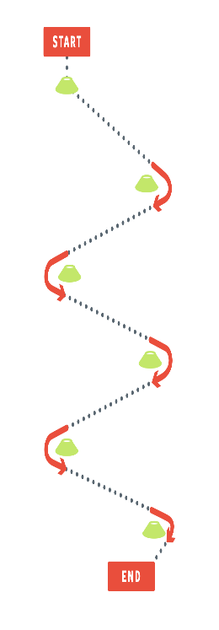

|  |  |
| --- | --- |
| **SECONDS** | **POINTS** |
| 6-8 | 4 |
| 9-10 | 3 |
| 11-12 | 2 |
| 12 & Slower | 1 |

**EVENT #3: PASSING**

**Purpose:** To measure the participant’s ability to throw a football accurately.

**Equipment:** Cones, an intermediate (youth) size football and measuring tape.

**Set-Up:** Set four cones into a square target area spread three yards apart. Set cones at throwing distance of 10-15-20 yards from the target area (see diagram below).

**Video Link:** <https://www.youtube.com/watch?v=crJpoGy896k>

**Instructions:** Participants standing at the throwing distance cones will pass to their coach/volunteer while the coach/volunteer is standing in the target box. Each participant will throw 2 times from the distance of 10-15 and 20- yards. When the coach/volunteer catches the pass being thrown from 10-yards without stepping out of the target box that counts as one point. From 15-yard, 2 points and 20-yards, 3 points. If the participant throws the ball on target but the coaches drop the ball, participant will receive those points.

**Scoring:** Each participant gets two passing attempts from the 10, 15 and 20-yard marker (please see below points awarded for each correct pass).

|  |  |
| --- | --- |
| Pass from 10 yards | 1 point |
| Pass from 15 yards | 2 points |
| Pass from 20 yards | 3 points |

3yds

20 15 10 yds

3 pts 2 pts 1 pt

3yds

**EVENT #4 – CATCHING**

**Purpose:** To measure participant’s ability to catch a football.

**Equipment:** Cones, an intermediate (youth) size football and measuring tape.

**Set-Up:** Set four cones into a square target area spread three yards apart. Set cones at throwing distance of 10-15-20 yards from the target area (see diagram below).

**Video Link:** <https://www.youtube.com/watch?v=loUaLQfHz0k>

**Instructions:** Coach/volunteer will pass the football to the participant while they are standing in the target box. Coach/volunteer will pass the football 2 times from the 10, 15 and 20-yard marker. Once the participant catches the pass from the 10-yard mark that counts as one point. From the 15-yard mark two points and from the 20-yard mark three points. If the coach over throws or throws to short a re-throw will be given. If the participant catches the poor pass. Points will be awarded and no re-throw is needed.

**Scoring:** Each participant gets two catching attempts from the 10, 15 and 20-yard marker (please see below points awarded for each correct pass).

|  |  |
| --- | --- |
| Catch from 10 yards | 1 point |
| Catch from 15 yards | 2 points |
| Catch from 20 yards | 3 points |

3yds

20 15 10 yds

3 pts 2 pts 1 pt

3yds



**FOOTBALL SKILLS**

**SPRING 2025**

**Team ROSTER**

**PLEASE FILL IN ALL SECTIONS**

School Name: ______________________________ Head Coach __________________________________

Assistant Coach(es) _________________________________, __________________________________

|  |  |  |  |  |  |  |  |
| --- | --- | --- | --- | --- | --- | --- | --- |
|  | **Player Name** | **Athlete** | **Buddy** | **Gender** | **Birth Date** | **Grade** | **Needs Assistance(Y/N)?** |
| 1. |  |  |  |  |  |  |  |
| 2. |  |  |  |  |  |  |  |
| 3. |  |  |  |  |  |  |  |
| 4. |  |  |  |  |  |  |  |
| 5. |  |  |  |  |  |  |  |
| 6. |  |  |  |  |  |  |  |
| 7. |  |  |  |  |  |  |  |
| 8. |  |  |  |  |  |  |  |
| 9. |  |  |  |  |  |  |  |
| 10. |  |  |  |  |  |  |  |
| 11. |  |  |  |  |  |  |  |
| 12. |  |  |  |  |  |  |  |

**Notes:**

Please list all athletes first, followed by buddies.

* The minimum is at least 3 and no more than 5 unified partners per team of 10.
* Athlete = Student from special education,
* Buddy = Student from general education who is assisting athlete.



INDIVIDUAL SKILLS REGISTRATION: 40-YARD DASH

School Name:_____________________________

***ONLY USE AN ATHLETE BUDDY DURING THE EVENT IF NEEDED.***

|  |  |  |  |
| --- | --- | --- | --- |
| **Name** | | **Time** | **Name of Athlete’s Buddy**  **(if using one)** |
| 1. |  |  |  |
| 2. |  |  |  |
| 3. |  |  |  |
| 4. |  |  |  |
| 5. |  |  |  |
| 6. |  |  |  |
| 7. |  |  |  |
| 8. |  |  |  |
| 9. |  |  |  |
| 10. |  |  |  |
| 11. |  |  |  |
| 12. |  |  |  |

Please complete and submit this form to the Unified Champions Schools Manager by February 17 2023, via e-mail: [unify@sohawaii.org](mailto:unify@sohawaii.org).

**Special Olympics Coaches Code of Conduct**

Special Olympics is committed to the highest ideals of sport and expects all coaches to honor sport and Special Olympics. This is the SOI and SOHI Coaches Code of Conduct. Local Delegations and Area Programs may also have Codes of Conduct specific to their program with certain specifications not included below. All Special Olympics coaches agree to observe the following code:

**Respect for Others:**

I will respect the rights, dignity and worth of athletes, coaches, officials, other volunteers, friends and spectators in Special Olympics.

I will treat everyone equally regardless of sex, ethnic origin, religion or ability.

I will be a positive role model for the athletes I coach.

**Ensure a Positive Experience:**

I will ensure that for each athlete I coach, the time spent with Special Olympics is a positive experience.

I will respect the talent, developmental stage and goals of each athlete.

I will ensure each athlete competes in events that challenge that athlete’s potential and are appropriate to that athlete’s ability.

I will be fair, considerate and honest with athletes and communicate with athletes using simple, clear language.

I will ensure that accurate scores are provided for entry of an athlete into any event.

I will instruct each athlete to perform to the best of the athlete’s ability at all preliminary competition and finals competition in accordance with the Official Special Olympics Sports Rules.

**Act Professionally and Take Responsibility for My Actions:**

My language, manner, punctuality, preparation and presentation will demonstrate high standards.

I will display control, respect, dignity and professionalism to all involved in the sport (athletes, coaches, opponents, officials, administrators, parents, spectators, media, etc.).

I will encourage athletes to demonstrate the same qualities.

I will not drink alcohol, smoke or take illegal drugs while representing Special Olympics at training sessions, during competition, or at any Special Olympics event or function.

I will refrain from any form of personal abuse towards athletes and others, including verbal, physical and emotional abuse.

I will be alert to any form of abuse from other sources directed toward athletes in my care.

**Quality Service to the Athletes**

I will seek continual improvement through performance evaluation and ongoing coach education.

I will be knowledgeable about the Sports Rules and skills of the sport(s) I coach.

I will provide a planned training program.

I will keep copies of the medical, training and competition records for each athlete I coach.

I will follow the Special Olympics Hawaii and National Federation/Governing Body rules for my sport(s).

**Health and Safety of Athletes**

I will ensure that the equipment and facilities are safe to use.

I will ensure that the equipment, rules, training and environment are appropriate for the age and ability of the athletes.

I will review each athlete’s medical form and be aware of any limitations on that athlete’s participation noted on that form.

I will encourage athletes to seek medical advice when required.

I will maintain the same interest and support toward sick and injured athletes.

I will allow further participation in training and competition only when appropriate.

**Violations of the Code of Conduct:**

I understand that if I violate this Code of Conduct I will be subject to a range of consequences, up to and including being prohibited from coaching in Special Olympics.

Furthermore, I understand that I accept the responsibility for the behavior of the athletes under my supervision.

Should the behaviors and/or attitude of any coach or other faction of the member organization be contrary to the principles, goals, or philosophies of Special Olympics, then one or more of the following steps may be taken by the Games Committee, Sport Officials, or other representatives of Special Olympics Hawaii in an effort to alleviate the situation without further affecting Special Olympic athletes or the competition:

The coach may be notified of the undesirable behavior and requested to remedy the situation for continued participation, ***and/or*** the coach may be requested to withdraw personally, or as a team or organization, from the remainder of the event or tournament.

In the event of extreme or repeated behavior contrary to the best interests of Special Olympics, Special Olympics may:

Prevent the coach, team organization, or specific members of the delegation from participating in any or all Special Olympics events for a specified period of time, ***and/or*** prevent the coach, team, organization, or specific members of the delegation from participating in Special Olympics indefinitely.

**Special Olympics Hawaii Athletes/ Unified Partners Code of Conduct**

Special Olympics Hawai’i is committed to the highest ideals of sport and expects all athletes to honor sports and Special Olympics. The following code of conduct applies to in-person events, virtual events and activities (Zoom, etc.) and on relevant social media platforms. All athletes and Unified Partners agree to the following code:

**Athlete/ Partner Standards of Behavior**

* I will practice good sportsmanship.
* I will learn and follow the rules of my sport.
* I will act in ways that bring respect to my coaches, team, Special Olympics, and me.
* I will attend 75% or more of practices.
* I will participate in all activities as deemed necessary by my Head Coach or Head of Delegation.
* I will always try my best during training, divisioning events, and competition.
* I will obey all safety rules.
* I will listen to and respect my coaches and officials and ask questions when I do not understand.
* I will not “hold back” in preliminary competitions just to get into an easier finals competition division.
* I will abide by and follow all laws, Special Olympics Hawai’i rules, and National Federation/Governing Body rules for my sport(s).
* I will not use or bring alcohol, drugs/controlled substances, or tobacco products at/to any Special Olympics event (practices, competitions, fundraisers, etc.).
* I will not verbally insult or abuse others or use inappropriate language (swearing). This applies to in-person, virtual and social media settings.
* I will not possess harmful or threatening weapons.
* I will not act in a violent, sexually inappropriate or disruptive manner with other athletes, coaches, volunteers, or staff. This includes inappropriate or unwanted physical, verbal, or sexual actions or behaviors, both in-person and on-line.

**Disciplinary Measures for violations of the Code of Conduct**

Minor Offenses: non-illegal or non-aggressive behaviors

1. 1st offense – verbal warning
2. 2nd offense – written warning with the possibility of short-term suspension, depending on severity of violation. Consequences may include:

a) Removal from practice(s)

1. Removal or suspension from Area/Regional competition
2. Removal or suspension from State Games, a season, or a longer period of time
3. 3rd offense – Suspension from program for a period to be determined based on severity and timing of the current and past violations. Suspensions may range from one season to three years. If prior violations are minor, and/or not recent history, suspensions will be reviewed.

Major Offenses: Illegal acts and aggressive behaviors including sexual harassment, physical assault and threats of physical violence

1. Immediate suspension from the program, AND
2. Suspension or Removal from the SOHI program, suspension length determined by the SOHI Risk Management Group.

All disciplinary action may be appealed to the SOHI Appeals Committee by the athlete/ partner and/ or their legal guardian.

Note: All offenses will be documented and kept on file.

**Travel to competitions or events:** Athletes and Youth (8-17) Partners

In order for any Special Olympics Hawai’i athlete/youth partner to travel to a Regional or State competition they must meet the following travel requirements.

* Be able to travel with a Special Olympics designated chaperone for the duration of the event, including flights.
* Be able to independently manage the activities and skills of daily living, i.e. toileting, showering, personal hygiene, etc., with minimal help.
* Cannot be a danger to themselves or others.
* Cannot be a flight risk and must listen to instructions from their chaperone, coaches and Head of Delegation.
* Be able to compete in their events independently, or only with the level of assistance allowed in the rules for their specific events.

Athlete/ Partner:

I understand that I am to abide by this Code of Conduct, I will be subject to a range of consequences by Special Olympics Hawai’i up to and including not being allowed to participate.