

***Basketball***

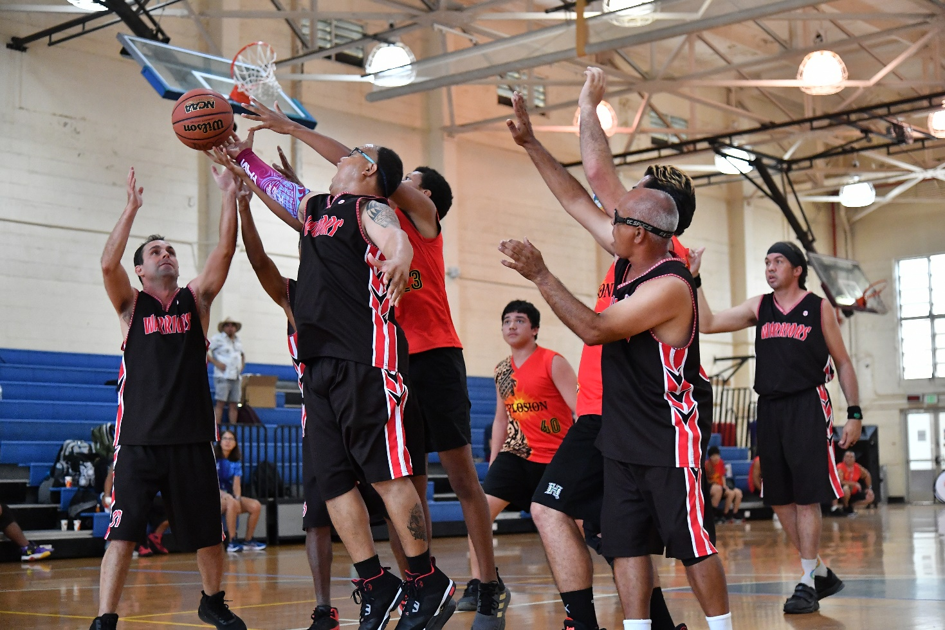

***Sport Information Guide***

***Rules and Guidelines***

## *Fall 2025* TABLE OF CONTENTS

**SOHI BASKETBALL GUIDELINES AND RULES**

Page #

Section A - General Rules 3

Section B – Important Dates 4

Section C – Training Policy 4

Section D - Official Events 4

Section E – Divisions 4

Section F – Uniforms 5

Section G – Equipment 6

Section H - Game Roster, Players, and Substitutes 6

Section I – Unified Team Basketball 6

Section J - The Game 7

Section K - Divisioning Rounds 8

Section L – Violations 8

Section M - Fouls and Penalties 8

Section N - Officials and Their Duties 9

Section O - Coaches and Their Responsibilities 9

Section P – Individual Skills Contest 10

Section Q – Skills Assessment Tests 13

Coaches Code of Conduct 15

Athletes Code of Conduct 17

**SPECIAL OLYMPICS MISSION STATEMENT:**

The mission of Special Olympics is to provide year-round sports training and athletic competition in a variety of Olympic-type sports for children and adults with intellectual disabilities, giving them continuing opportunities to develop physical fitness, demonstrate courage, experience joy and participate in a sharing of gifts, skills and friendship with their families, other Special Olympics athletes and the community.

**Rule Changes, Additions or Clarifications from the 2024 rules.**

**No major rule changes from the 2024 rules**

**SOHI dates have been updated: Page 4**

For more information please go to **www.SOHawaii.org** or e-mail Greg Terhune at [**sohisports@SOHawaii.org**](mailto:sohisports@SOHawaii.org)**.**

# SOHI BASKETBALL RULES AND REGULATIONS

These Official Special Olympics Hawaii (SOHI) Rules shall govern all SOHI Basketball competitions. SOHI has created these rules based upon The National Federation of State High School Associations (NFHS) Rules for Basketball. NFHS rules shall be employed except when they are in conflict with the Official SOHI Basketball Rules. In such cases, these Official SOHI Basketball Rules shall apply.

### SECTION A - GENERAL RULES

1. Each Special Olympics Athlete is required to have a valid Medical form (Application for Participation) filled out by a certified physician, and a signed Release form in order to participate. Each Unified Partner must fill out a Unified Sports® partner release form. Unified Partners ages 16 and above must fill out a Volunteer Information form, and meet Class “A” Volunteer criteria in order to participate. Athletes or Partners without the appropriate forms are ineligible to participate. These forms must be on file with their Area Director and with the State Office.
2. All Coaches and Assistant Coaches must fill out a Volunteer Information Form and meet Class “A” Volunteer criteria in order to participate.
3. All Head Coaches and Assistant Coaches must complete NFHS or CDC Concussion Training.
4. Each team must have a Head Coach with current SOHI certification in Basketball to participate in the Holiday Classic. Additionally, all Unified Teams must have a Head Coach who has completed the Unified Sports Training.
5. For more information regarding Coaches Certification and Class A Volunteer requirements please see the following: <https://sohawaii.org/get-involved/coaches/>
6. Athletes and Unified Partners must participate in a training program run by a registered delegation. Athletes and Partners must comply with Delegation, Area, and State training policies and standards and must meet minimum attendance requirements set by the Delegation or Area to participate in Area, Regional, or State competition.
7. Each team is required to play in their qualifying Area or Regional tournament prior to participation in the Holiday Classic tournament. Only athletes who played in their Area or Regional qualifying tournament can play at the Holiday Classic.
8. Each player must play at least one quarter (7 ½ minutes) of play in its entirety, unless the player is physically unable. If they are unable, they must play 7 ½ minutes within 2 consecutive quarters. Scorekeepers must be notified in this instance.
9. Injured players are not required to play. Players removed for disciplinary reasons are not required to play. Coaches must notify the scorekeeper prior to the game if players on the approved tournament roster will not be playing due to injury or disciplinary reasons.
10. Any player ejected from a game will be ineligible to play in the team’s next game.
11. No Make-up games will be allowed to qualify athletes who have missed Area or Regional competition.
12. Individual Skills Athletes must compete in a qualifying Area of Regional competition to advance to Holiday Classic competition.
13. Delegations with multiple teams should identify these teams with different team names, not numbers or letters
14. All delegations must abide by the most current COVID Guidelines and Protocols.

**SECTION B – IMPORTANT DATES – BASKETBALL**

|  |  |
| --- | --- |
| Event | Date/Deadline |
| Official Training May Begin | August 19 |
| Basketball Coaches Clinic | August 23 |
| All Athletes must begin training/ All Medicals due/  Last day to transfer delegations | By September 1 |
| Official Training Must Begin for Delegations/ Teams | By September 1 |
| Registration Deadlines for Area or Regional Competition | Check with Area Director/ HoD |
| Area or Regional Competitions | September -October |
| Holiday Classic | November 22-23 |

**SECTION C – SPECIAL OLYMPICS HAWAII TRAINING POLICY**

1. Delegations must offer enough training sessions so that athletes have the opportunity to gain the skills and fitness levels required to be successful in their specific events.
2. Athletes must attend enough training sessions gain the skills and fitness levels required to be successful in their specific events.
3. SOHI recommends that every athlete is offered at least two training opportunities per week with every training opportunity being at least 1 – 1 ½ hours in duration (Per the Global Strategic Plan). However, SOHI will accept a minimum of one training session a week for at least 90 minutes.
4. Area/Regional Competitions and scrimmages count as training sessions.
5. SOHI requires that Athletes/ Unified Partners attend a minimum of 75% of training sessions offered by their delegation. Delegations may require a higher attendance percentage, but may not require athletes/Unified Partners to attend more than 90% of training sessions.
6. Athletes with documented injury or illness during a season may receive an exemption from the above policy, but must participate in a minimum of 50% of practices during the season and must have the requisite skills, and be physically capable (strength, fitness, injury/sickness fully healed with doctor’s clearance) of successfully participating in the sport as determined by their Head Coach. Athletes still must play at Area or Regional competition in order to compete at the Holiday Classic.

#### SECTION D - OFFICIAL EVENTS

1. Team Basketball (Traditional 5-on-5)
2. Unified Team Basketball (Elementary, Middle School, and High School Divisions Only)
3. Individual Skills Competition (ISC)
4. Future Stars Basketball Skills (ISC for 6-7 year olds)

### SECTION E - DIVISIONS

Traditional Team Basketball divisions will be created solely on the basis of the ability levels of the teams entered in the tournament. However, if enough youth teams (8-15) are entered in a tournament, a youth division will be created.

1. The Head Coach must submit the scores from the three Basketball Skills Assessment Tests (BSAT), e.g., rebounding, dribbling, and perimeter shooting, for each player on his/her roster prior to competition. These tests are found in Section O.
2. The team score shall be determined by adding the top seven players’ scores and then dividing that total by seven. Unified teams shall use the scores of the top 4 athletes and the top 3 partners.
3. Teams are initially grouped in divisions based on their BSAT score and past performance.
4. At Area/Regional competition, a classification round of games may be conducted as a means of finalizing the divisioning process. (See Section H.) At the Holiday Classic, divisions will be based on Area/Regional competition evaluations, past results and BSAT’s.

**Unified Team Basketball Divisions** will be created based on the School/Age level of the team.

1. Separate divisions will be created for Elementary School, Middle School and High School Teams. Unified Basketball is not available for adults. The school/age level of the oldest athlete or partner will determine the school/age level of the team. In certain circumstances, teams may play against teams from another school/age level, but only as long as it is safe to do so.
2. Separate divisions may be created within a school/age level if there are enough teams and if there is a great disparity among the skill levels of the teams within their school/age level.
3. Athletes/Partners may play “up” one age division if they are physically ready and have the requisite skills to play in an older age group. For example, a Middle School athlete may play on a team made up of High School students. If officials deem it unsafe for a player to play in a game, the player may be removed for safety reasons. If a team has the requisite skills, they may be placed in an older age group if there is not enough competition for them in their age group.
4. Unified Teams are still required to complete the assessment tests and follow all Division guidelines above.

### SECTION F - UNIFORMS

1. All players must wear numbered uniforms. Only the digits 0-5 may be used with the highest possible number being 55. Numbers are required on both sides of the jersey and shall be at least 6 inches high on the back and 4 inches high on the front, and not less than ¾ inch in width.
2. All players must wear gym, court, or tennis shoes. Encourage your players not to wear black soft sole shoes, as they will leave black marks on the court.
3. All members of a team must wear the same color uniform jersey. If a T-shirt is worn under a tank top, it should be the same or a similar color. (No cut or ragged edges).
4. All players should wear gym shorts of the same color. Players cannot wear jeans or cutoffs. Sweatpants may be worn for religious or custom related reasons.
5. Those players who wear eyeglasses while playing are required to wear a strap to hold the glasses in place.
6. All athletes must remove all jewelry, watches, bracelets, earrings, necklaces, rings, etc. prior to each game.
7. Head coverings are for religious reasons only and must be of a single, solid color, and unadorned.
8. If a medical device is worn, it must be approved prior to competition. This includes any device worn that covers the face, lower arm (from the elbow to the wrist), knee, or lower leg. A document from a Doctor indicating the purpose and composition of the device will assist in addressing any risk management issues.

### SECTION G - EQUIPMENT

1. Special Olympics Basketball calls for the use of NFSHSA standard basketball equipment including the regulation basketball, baskets, and basket heights.
2. A standard size ball shall be used for all divisions except youth or Elementary SchoolDivisions. A smaller basketball, Size 6, (28 ½” in circumference and between 18-20 oz. in weight) WILL be used for youth/elementary divisions.
3. All levels and divisions will play with a regulation 10 ft. goal, except Elementary School Divisions. The height of the goal may be lowered in these divisions if possible.

### SECTION H - GAME ROSTER, PLAYERS, AND SUBSTITUTES

1. A line-up must be submitted by the coach to the official scorekeeper ten minutes prior to the scheduled game time.
2. All team members must be listed on the roster and made available to the official scorekeeper and opposing team. Failure to list a roster player for insertion in the official scorebook will result in a technical foul.
3. A team must start the game with five players, but may play with as few as 3 players during the game. Teams with less than 3 players on the court will forfeit the game.
4. Rosters should consist of between 6 to 10 players. Teams with 12 or more players must split into 2 teams.
5. Substitutions may be made any time the referee’s whistle is blown to stop play, during time-outs or prior to the beginning of a half or quarter. Substitutes will report to the scorer at the score table who will then notify the referee of substitutions. Substitutions may not be made after a basket.
6. Each player must play at least one quarter (7 ½ minutes) of play in its entirety, unless the player is physically unable. If they are unable, they must play 7 ½ minutes within 2 consecutive quarters. Scorekeepers must be notified in this instance. If it is found that an eligible team member did not play the required amount, the game will be declared a forfeit. It is the responsibility of the Head Coach to ensure that all players play the required amount of time.
7. Injured players are not required to play. Players removed for disciplinary reasons are not required to play. Coaches must notify the scorekeeper prior to the game if players on the approved tournament roster will not be playing due to injury or disciplinary reasons.

### SECTION I – UNIFIED TEAM BASKETBALL (Elementary, Middle, and High School Divisions)

Player Development Model:

What differentiates Unified Sports Player Development from competitive Unified Sports is: 1) teammates are not required to be of similar abilities, and 2) teammates of higher abilities serve as mentors to assist teammates of lower abilities in developing sport-specific skills and tactics, as well as in successfully participating in a cooperative team environment. Because of differences in abilities, rule modifications are allowed to ensure meaningful involvement of all teammates. Additionally, the roles of higher ability players are to serve as mentors, facilitate cooperative team play, and not to dominate play. Guidelines for the Player Development Model are as follows:

1. Is an inclusive sports model
2. Has an approximately equal number of athletes and partners of similar age
3. Has higher ability players mentoring lower ability players
4. Develops players’ sport-specific skills and tactics to successfully participate in a team environment.
5. Provides a competitive team sports experience that emphasizes cooperative play.
6. Has modified training and competition rules which define higher ability players’ roles as mentors, ensure meaningful involvement of all teammates and prevent player domination.
7. In order for a game to be played by the rules and at the same time allow for the safe and meaningful involvement of all team members, teammates of higher ability must adjust their level of play to serve as mentors and facilitators.

The following rules and guidelines apply:

1. The roster shall contain a proportionate number of athletes and partner. A full roster of approximately five Athletes and four Unified Partners is recommended.
2. Five players are required per team to start a game. The on-court lineup shall always consist of three athletes and two partners, unless there are fewer than 5 eligible players. There can never be more partners than athletes on the court. With four eligible players a team can play with two athletes and two partners. With three eligible players a team can play with two athletes and one partner. A team will forfeit with less than three eligible players.
3. Athletes must wear even number uniforms; Unified Partners must wear odd number uniforms.
4. Each team shall have a non-playing adult coach responsible for the lineup and conduct of the team during competition. The team should be organized under the guidance of a trained coach who understands and adopts the principles of Special Olympics and Unified Sports, and has knowledge of the rules, techniques, strategies and training regimens of the selected sport.
5. Every player must be meaningfully involved in the team. This means that every player must be given an opportunity to contribute to the success of his or her team through their unique skills and qualities. Every teammate: (a) demonstrates sufficient sport-specific skills and game understanding; (b) plays a valued role on the team that emphasizes his or her personal talents; and (c) has an opportunity to play without a heightened risk of injury.
6. Team members should be made up of athletes and partners who are of similar ages. In consideration of safety and dominant play, individuals with significantly greater skill than the majority of their teammates must take on the role of mentor, and facilitate cooperative play, or they may be removed from competition.
7. All players on a Unified Sports team makes the commitment to attend every practice, support each other as equal teammates, and demonstrate respect and sportsmanship.

### SECTION J - THE GAME

1. In cases not specifically covered by the rules in this manual, the National Federation of State High School Associations, NFHS, rules will govern.
2. Games will be played as follows:
3. 8 minute pre-game warm-up
4. 7 ½ minute quarters (running time)
5. 1 minute intermission after the first and third quarters
6. 5 minute intermission at half-time
7. The clock will stop on dead balls and made field goals in the last two minutes of play of the fourth quarter and in overtime.
8. Each team has (2) one-minute time-outs per game. These time-outs can be used in either half. Each team will receive (1) time-out in overtime. Players or the Head Coach can call time-outs.
9. Overtime is two minutes. The clock stops on all dead balls and made field goals.
10. Teams must be ready to play within 5 minutes of the scheduled game time or a forfeit will be declared.

#### SECTION K – DIVISIONING ROUND

1. Divisioning games will be 6-8 minutes (determined at the tournament), running time. No warm-up time will be given. These games do not count toward standings or medals; they are used to ensure that teams are placed in divisions so that there is fair and equitable competition.
2. Each team must play their top five, or starting five, for at least the first four minutes of all divisioning round games. No substitutions will be allowed in the first 4 minutes. All players must play in the divisioning round games.
3. Athletes missing divisioning round games are ineligible to play in regulation games, unless given specific approval by the tournament committee.

### SECTION L – VIOLATIONS and ADAPTATIONS

1. “A” and “B” Divisions - Fouls and violations will be called in accordance with NFHS standards. Full-court pressing is allowed. The three-second rule in the lane will be enforced.

2. Lower Divisions & all Unified School Divisions - Calling of fouls and violations are more relaxed the lower the divisions are. Therefore “C” level, and Unified Middle School and High School teams are expected to play within NFSHA rules with only minor modifications, (i.e. one warning prior to 3-second lane violation calls, or referees may overlook minor traveling violations if they don’t affect play). In the Lowest Divisions, “D”, “E”, and Unified Elementary School, all the listed modifications may be used. The following modifications will be allowed:

* 1. The three-second lane will be eased. Players will be warned prior to the call. The three-second violation should be called whenever the offending player scores or rebounds.
  2. Players will be allowed continuous one or two hand dribbles with minimal hesitation. Players cannot gain an advantage over the opponent using a two handed dribble. Once the ball is picked up and held, the player must shoot or pass. An attempt to dribble again will be a violation.
  3. Players will be allowed two extra steps in starting or stopping a dribble. However, if the player scores or escapes the defensive pressure as a result of these extra steps, an advantage has been gained. Therefore, a violation is called immediately.
  4. Backcourt pressure is not allowed. The defensive team must retreat to beyond mid-court without attempting defensive resistance. An attempt to guard an offensive player prior to crossing half court will result in the referee stopping play and giving a warning to the defensive team. Each team will be allowed two warnings. A third violation will result in a technical foul. However, teams may attempt to play defense at any location on the court when the offensive team is attempting to fast break down the court. “B” Division teams will be allowed to full-court press.
  5. A player may be allowed a mild shuffle of his/her feet while holding the ball without changing position on the court. However, a player forced into traveling by defensive pressure will be called for the violation.
  6. Line violations on throw-ins and free throws will result in the athletes being called back to repeat the process. Repeated violations will result in loss of possession.
  7. Backcourt line violations will be enforced in all divisions.

**SECTION M - FOULS AND PENALTIES**

1. Each player will be allowed five fouls per game. The fifth foul will result in removal of that player from the game.
2. The Double Bonus (2 free throws) will be in effect on the seventh foul of each half.
3. Technical fouls will be assessed for unsportsmanlike conduct by any coach, player, team attendant or follower. Technical fouls committed by a player shall result in one free throw. If bench personnel commit the technical foul, the offended team is awarded two free throws. If the foul is flagrant (violent, vulgar, or abusive), two free throws shall be awarded and the offender shall be ejected from the game. Any third technical for the above reasons is considered a flagrant foul and will be treated as such. After all technical fouls, the team that is awarded the foul shot will also receive possession of the ball after the foul shot. The ball will be played in from half court.
4. The game will be forfeited when a team fails to report for play within five minutes after their scheduled game time. (If a team shows reasonable cause, i.e. bus breakdown, etc., the tournament director can allow the game to proceed without consequence, if the schedule allows).
5. Any player ejected from a game will be ineligible to play in the team’s next game.

### SECTION N - OFFICIALS AND THEIR DUTIES

1. Referees shall have the power to make all decisions on any point not specifically covered in the rules.
2. Officials shall penalize unsportsmanlike conduct by player, coach, spectator, and family member, by warning or ejection.
3. The Competition Committee and Sports Director shall be responsible for decisions relating to actions inconsistent with Special Olympics philosophy, reclassification, or official complaints.
4. The referee shall toss the ball just above the heads of the two centers at the start of the game and any overtime periods only. All other jump ball situations will be administered with the alternate possession rule, beginning with the team that failed to control the jump ball at the start of the game. The official scorer is responsible for keeping track of alternate possessions.

### SECTION O - COACHES AND THEIR RESPONSIBILITIES

1. Coaches shall remain within the team bench area while the game is in progress.
2. In the lowest division of the tournament only, teams can have one coach behind the basket on the opposite end of the court from their team bench. Teams cannot place coaches at any other spot around the court other than the team bench. After one warning teams will be called for a technical foul. Coaches are not allowed on the court during play. Coaches should only be placed behind the basket if necessary.
3. Coaches can meet with officials during warm-up to review rules in effect for their division.
4. Coaches are responsible for playing all members of their roster at least one quarter of every game.
5. Coaches must abide by the Coaches Code of Conduct (pgs.15-16).
6. Coaches are responsible for knowing and understanding the rules of the game, not only the modified rules in this manual, but also NFHS rules. To acquire your own NFHS Rule book contact them by Phone: (800) 776-3462, or through their Website: [www.nfhs.org](http://www.nfhs.org).

**SECTION P - INDIVIDUAL SKILLS CONTEST (ISC)**

* This event provides meaningful competition for athletes with lower ability levels. It is not for athletes who can already play the game.
* Three events comprise the Individual Skills Contest: Target Pass, Ten Meter Dribble, and Spot Shot.
* The athlete’s final score is determined by adding the scores achieved in each of these three events.
* Athletes will be pre-divisioned according to their total scores from these three events.
* Each event is diagrammed with the suggested number and placement of volunteers who will administer them. It is also suggested that the same volunteers remain at an event throughout the competition so that consistency is provided.

**ISC Event #1: Target Pass**

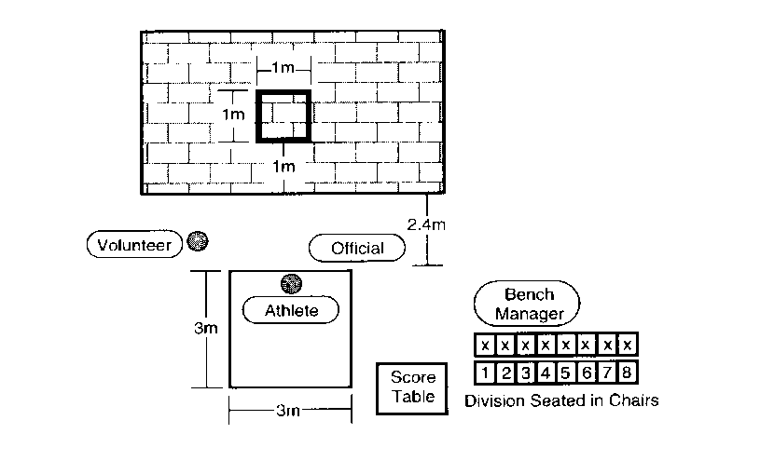

1. Purpose

To measure an athlete’s skill in passing a basketball.

1. Equipment

Two basketballs (for women’s and youth division competitions, a smaller basketball, Size 6, which is 28 1/2 inches in circumference and between 18-20 ounces in weight) may be used as an alternative, flat wall, chalk or floor tape, and measuring tape.

1. Description

* A 1m (3’3 1/2”) square is marked on a wall using chalk or tape.
* The bottom line of the square of the line shall be 1m (3’3 1/2) from the floor.
* A 3m (9’9”) square will be marked on the floor and 2.4m (7”) from the wall.
* The athlete must stand within the square.
* The leading wheel axle of an athlete’s wheelchair may not pass over the line.
* The athlete is given five passes.

1. Scoring

* The athlete receives 3 points for hitting the wall inside the square.
* The athlete receives 2 points for hitting the lines of the square.
* The athlete receives 1 point for hitting the wall but not in or on any part of the square.
* The athlete receives 1 point for catching the ball in the air or after one or more bounces while standing.
* The athlete receives 0 points if the ball bounces before hitting the wall.
* The athlete’s score will be the sum of the points from all five passes.

**ISC Event #2: Ten-meter Dribble**

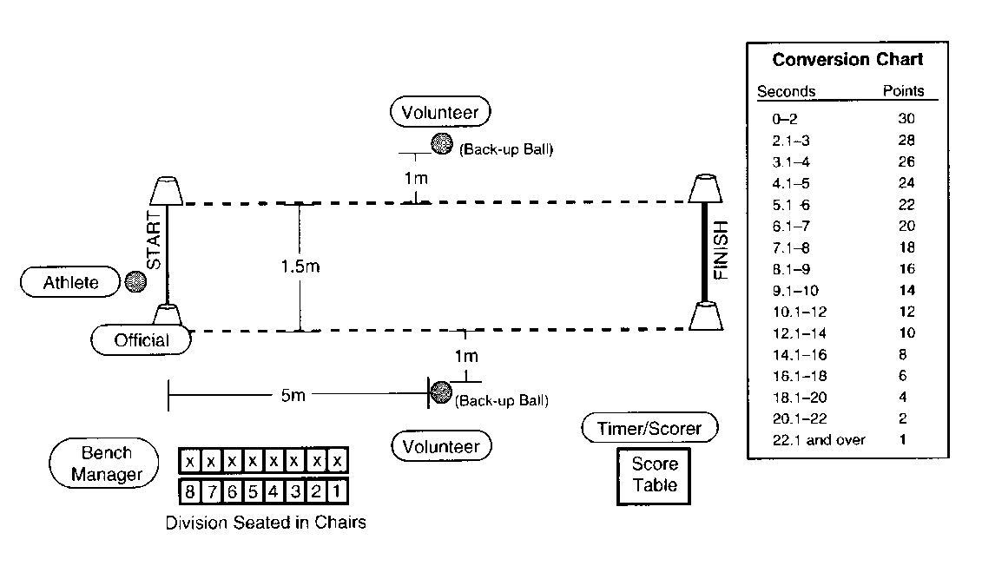

1. Purpose
2. To measure an athlete’s speed and skills in dribbling a basketball.
3. Equipment
4. Three basketballs (for women’s and youth division competitions, a smaller basketball, Size 6, which is 28 1/2 inches in circumference and between 18-20 ounces in weight) may be used as an alternative, four traffic cones, floor tape or chalk, measuring tape, and stopwatch.
5. Description

* The athlete begins from behind the start line and between the cones.
* The athlete starts dribbling and moving when the Official signals.
* The athlete dribbles the ball with one hand for the entire 10m (32’9 3/4”).
* A wheelchair athlete must alternate taking 2 pushes followed by two dribbles for legal dribbling.
* The athlete must cross the finish line between the cones and must pick up the basketball to stop the dribble.
* If an athlete loses control of the ball, the clock continues to run. The athlete can recover the ball. However, if the ball goes outside the 1.5m lane, the athlete can either pick up the nearest back-up basketball or recover the errant ball to continue the event.

1. Scoring

* The athlete will be timed from the signal “Go” to when he/she crosses the finish line between the cones and picks up the basketball to stop the dribble.
* A one-second penalty will be added every time the athlete illegally dribbles (i.e. two-hand dribbles, carries the ball, etc.).
* The athlete will receive two trials.
* Each trial is scored by adding penalty points to the time elapsed and converting the total to points based on the Conversion Chart.
* The athlete’s score for the event is his/her best of the two trials converted into points.
* (In case of a tie, the actual time will be used to differentiate place).

**ISC Event #3: Spot Shot**



1. Purpose
2. To measure an athlete’s skill in shooting a basketball.
3. Equipment
4. Two basketballs (for women’s and youth division competitions, a smaller basketball, Size 6, which is 28 1/2 inches in circumference and between 18-20 ounces in weight) may be used as an alternative, floor tape or chalk, measuring tape and a 3.05m (10 feet) regulation goal with backboard (for junior division competition an 8 feet goal may be used as an alternative, if available).
5. Description

* Six spots are marked on the floor. Start each measurement from a spot on the floor under the front of the rim. The spots are marked as follows:
* #1 & #2 = 1.5m (4’11” to the left and right plus 1m (3’3 1/2”) out.
* #3 & #4 = 1.5m (4’11” to the left and right plus 1.5m (4’11”) out.
* #5 & #6 = 1.5m (4’11” to the left and right plus 2m (6’6 3/4”) out.
* The athlete attempts two shots from each of six spots. The attempts are taken at spots #2, #4, and #6 and then at spots #1, #3, and #5.

1. Scoring

* For every field goal made at spots #1 and #2, two points are awarded.
* For every field goal made at spots #3 and #4, three points are awarded.
* For every field goal made at spots #5 and #6, four points are awarded.
* For any field goal attempt that does not pass **completely** through the basket but does hit either the backboard and/or the ring, one point is awarded.
* The athlete’s score will be the sum of the points from all 12 shots.

**The athlete’s final score for the Individual Skills Contest is determined by adding together the scores achieved in each of the three events**.

**SECTION Q - BASKETBALL SKILLS ASSESSMENT (BSAT)**

**BSAT - Dribbling**



1. Set-up

An area of the basketball court (preferably along a side-line or down the center line), six cones, floor tape, and four basketballs - one that the athlete is provided initially, two others that are for back-up in case the basketball bounces away, and one more to continue the test.

1. Test

Time: 60 seconds for one trial.

A player is instructed to dribble the ball while passing alternately to the right and to the left of six obstacles placed in a line, 2 meters (6’6 3/4”) apart, on a 12-meter course. The player can start to the right or to the left of the first obstacle but must pass each obstacle alternately, thereafter. **One point is awarded each time a cone is passed. (For example, if the player successfully dribbles the ball from the starting line, weaves in and out through the entire obstacle course one time, and places the ball down at the finish line, a score of five has been achieved).** When the last obstacle is passed and the FINISH line reached, the player puts the ball down, sprints back to the START for the next ball, and repeats the slalom. The player continues until 60 seconds have elapsed. If a player loses control of the ball, the clock continues to run. The player recovers the ball or picks up the nearest back-up ball and may re-enter at any point along the course.

1. Scoring

**One point is awarded each time a cone is passed. (For example, if the player successfully dribbles the ball from the starting line, weaves in and out through the entire obstacle course one time, and places the ball down at the finish line, a score of five has been achieved).** The player must use legal dribbles and must have control of the ball during a midpoint-to-next-midpoint space in order to get credit for that cone successfully passed). The player’s score is how many cones (midpoints) he/she successfully passes in 60 seconds.

1. Staging

Volunteers administer the test and are not to interfere with any player who is performing the test. Volunteer A will instruct the group doing this particular test while Volunteer B demonstrated the actual test. Volunteer A will give a basketball to the player who will take the test, **signal by raising their arm that the test is about to begin**, ask him/her if ready, will then say: “Ready, Go,” **blow a low whistle to indicate that the test has begun**, and will count how many cones the player passes in 60 seconds. Volunteers B and C who are standing behind the extra balls will retrieve and replace the basketball whenever it goes out of play. Volunteer D will time and record the athlete’s score. Each volunteer is to administer the test and manage the area only.

**BSAT - Perimeter Shooting**



1. Set-up

A goal, the official NGB free throw lane, floor tape, and two basketballs - one that the athlete is provides initially, and another that is for back up in case the basketball rebounds away.

1. Test

Time: one trial of one minute.

* A player stands at the juncture of the free-throw line and lane, either to the left or right.
* The player dribbles toward the goal and attempts a field goal of his/her choice outside the 2.75 meter (9’) arc. This attempt must be taken anywhere outside the 2.75 meter arc marked off by a dotted line. (This arc intersects with the free-throw restraining circle.)
* The player then rebounds the basketball (made or missed shot) and dribbles anywhere outside the arc before attempting another field goal.
* The player shall make as many field goals as described above in a one minute trial.

1. Scoring

Two points are awarded for each field goal made within the one minute trial.

1. Staging

Volunteers administer the test and are not to interfere with any player who is performing the test. Volunteer A will instruct the group doing this particular test while Volunteer B demonstrates the actual test. Volunteer A will give a basketball to the player who will take the test, **signal by raising their arm that the test is about to begin,** ask him/her if ready, will thensay: “Ready, Go,” **blow a low whistle to indicate that the test has begun**, and will count how many field goals the player makes in two minutes. Volunteer B who is standing behind the extra ball will retrieve and replace the basketball whenever it goes out of play. Volunteer C will time and record the athlete’s score. Each volunteer is to administer the test and manage thearea only.

**Special Olympics Coaches Code of Conduct**

Special Olympics is committed to the highest ideals of sport and expects all coaches to honor sport and Special Olympics. This is the SOI and SOHI Coaches Code of Conduct. Local Delegations and Area Programs may also have Codes of Conduct specific to their program with certain specifications not included below. All Special Olympics coaches agree to observe the following code:

**Respect for Others:**

I will respect the rights, dignity and worth of athletes, coaches, officials, other volunteers, friends and spectators in Special Olympics.

I will treat everyone equally regardless of sex, ethnic origin, religion or ability.

I will be a positive role model for the athletes I coach.

**Ensure a Positive Experience:**

I will ensure that for each athlete I coach, the time spent with Special Olympics is a positive experience.

I will respect the talent, developmental stage and goals of each athlete.

I will ensure each athlete competes in events that challenge that athlete’s potential and are appropriate to that athlete’s ability.

I will be fair, considerate and honest with athletes and communicate with athletes using simple, clear language.

I will ensure that accurate scores are provided for entry of an athlete into any event.

I will instruct each athlete to perform to the best of the athlete’s ability at all preliminary competition and finals competition in accordance with the Official Special Olympics Sports Rules.

**Act Professionally and Take Responsibility for My Actions:**

My language, manner, punctuality, preparation and presentation will demonstrate high standards.

I will display control, respect, dignity and professionalism to all involved in the sport (athletes, coaches, opponents, officials, administrators, parents, spectators, media, etc.).

I will encourage athletes to demonstrate the same qualities.

I will not drink alcohol, smoke or take illegal drugs while representing Special Olympics at training sessions, during competition, or at any Special Olympics event or function.

I will refrain from any form of personal abuse towards athletes and others, including verbal, physical and emotional abuse.

I will be alert to any form of abuse from other sources directed toward athletes in my care.

**Quality Service to the Athletes**

I will seek continual improvement through performance evaluation and ongoing coach education.

I will be knowledgeable about the Sports Rules and skills of the sport(s) I coach.

I will provide a planned training program.

I will keep copies of the medical, training and competition records for each athlete I coach.

I will follow the Special Olympics Hawaii and National Federation/Governing Body rules for my sport(s).

**Health and Safety of Athletes**

I will ensure that the equipment and facilities are safe to use.

I will ensure that the equipment, rules, training and environment are appropriate for the age and ability of the athletes.

I will review each athlete’s medical form and be aware of any limitations on that athlete’s participation noted on that form.

I will encourage athletes to seek medical advice when required.

I will maintain the same interest and support toward sick and injured athletes.

I will allow further participation in training and competition only when appropriate.

**Violations of the Code of Conduct:**

I understand that if I violate this Code of Conduct I will be subject to a range of consequences, up to and including being prohibited from coaching in Special Olympics.

Furthermore, I understand that I accept the responsibility for the behavior of the athletes under my supervision.

Should the behaviors and/or attitude of any coach or other faction of the member organization be contrary to the principles, goals, or philosophies of Special Olympics, then one or more of the following steps may be taken by the Games Committee, Sport Officials, or other representatives of Special Olympics Hawaii in an effort to alleviate the situation without further affecting Special Olympic athletes or the competition:

The coach may be notified of the undesirable behavior and requested to remedy the situation for continued participation, ***and/or*** the coach may be requested to withdraw personally, or as a team or organization, from the remainder of the event or tournament.

In the event of extreme or repeated behavior contrary to the best interests of Special Olympics, Special Olympics may:

Prevent the coach, team organization, or specific members of the delegation from participating in any or all Special Olympics events for a specified period of time, ***and/or*** prevent the coach, team, organization, or specific members of the delegation from participating in Special Olympics indefinitely.

**Special Olympics Hawaii Athletes/ Unified Partners Code of Conduct**

Special Olympics Hawai’i is committed to the highest ideals of sport and expects all athletes to honor sports and Special Olympics. The following code of conduct applies to in-person events, virtual events and activities (Zoom, etc.) and on relevant social media platforms. All athletes and Unified Partners agree to the following code:

**Athlete/ Partner Standards of Behavior**

* I will practice good sportsmanship.
* I will learn and follow the rules of my sport.
* I will act in ways that bring respect to my coaches, team, Special Olympics, and me.
* I will attend 75% or more of practices.
* I will participate in all activities as deemed necessary by my Head Coach or Head of Delegation.
* I will always try my best during training, divisioning events, and competition.
* I will obey all safety rules.
* I will listen to and respect my coaches and officials and ask questions when I do not understand.
* I will not “hold back” in preliminary competitions just to get into an easier finals competition division.
* I will abide by and follow all laws, Special Olympics Hawai’i rules, and National Federation/Governing Body rules for my sport(s).
* I will not use or bring alcohol, drugs/controlled substances, or tobacco products at/to any Special Olympics event (practices, competitions, fundraisers, etc.).
* I will not verbally insult or abuse others or use inappropriate language (swearing). This applies to in-person, virtual and social media settings.
* I will not possess harmful or threatening weapons.
* I will not act in a violent, sexually inappropriate or disruptive manner with other athletes, coaches, volunteers, or staff. This includes inappropriate or unwanted physical, verbal, or sexual actions or behaviors, both in-person and on-line.

**Disciplinary Measures for violations of the Code of Conduct**

Minor Offenses: non-illegal or non-aggressive behaviors

1. 1st offense – verbal warning
2. 2nd offense – written warning with the possibility of short-term suspension, depending on severity of violation. Consequences may include:

a) Removal from practice(s)

1. Removal or suspension from Area/Regional competition
2. Removal or suspension from State Games, a season, or a longer period of time
3. 3rd offense – Suspension from program for a period to be determined based on severity and timing of the current and past violations. Suspensions may range from one season to three years. If prior violations are minor, and/or not recent history, suspensions will be reviewed.

Major Offenses: Illegal acts and aggressive behaviors including sexual harassment, physical assault and threats of physical violence

1. Immediate suspension from the program, AND
2. Suspension or Removal from the SOHI program, suspension length determined by the SOHI Risk Management Group.

All disciplinary action may be appealed to the SOHI Appeals Committee by the athlete/ partner and/ or their legal guardian.

Note: All offenses will be documented and kept on file.

**Travel to competitions or events:** Athletes and Youth (8-17) Partners

In order for any Special Olympics Hawai’i athlete/youth partner to travel to a Regional or State competition they must meet the following travel requirements.

* Be able to travel with a Special Olympics designated chaperone for the duration of the event, including flights.
* Be able to independently manage the activities and skills of daily living, ie. toileting, showering, personal hygiene, etc., with minimal help.
* Cannot be a danger to themselves or others.
* Cannot be a flight risk and must listen to instructions from their chaperone, coaches and Head of Delegation.
* Be able to compete in their events independently, or only with the level of assistance allowed in the rules for their specific events.

Athlete/ Partner:

I understand that I am to abide by this Code of Conduct, I will be subject to a range of consequences by Special Olympics Hawai’i up to and including not being allowed to participate.